**Why not only Cloud but FOG computing is necessary in IoT paradigm: An Overview**

**IoT**

The Internet of Things (IoT) paradigm is based on intelligent and self-configuring nodes (things) interconnected in dynamic and global network infrastructure. It represents one of the most disruptive technologies, enabling ubiquitous and pervasive computing scenarios. IoT is generally characterized by real world and small things with limited storage and processing capacity, and consequential issues regarding reliability, performance, security, and privacy [3].

**Issues faced by IoT applications**

With the development of IoT, Cyber-physical System (CPS), and Mobile Internet, various objects, including people, machines, things, are connected into information space in anywhere at any time. The unprecedented amounts and varieties of data are being are generated [1]. At the same time, there has also been a surging number and variety of powerful end-user, network edge, and access devices: smart phones, tablets, smart home appliances, small cellular base stations, edge routers, traffic control cabinets along the roadside, connected vehicles, smart meters, and energy controllers in a smart power grid, smart building controllers, industrial control systems, just to name a few. Many more smart clients and edge devices, such as drones, industrial and consumer robots, information-transmitting light-bulbs, computers on a stick, and button-sized radio frequency tuners, are following right behind [2].

According to the estimation and prediction of Cisco, there are more than 50 billion devices which will be connected to the Internet by 2020. And the data produced by people, machines, things and their interactions will reach 500 zettabytes, and 45% of IoT-created data will be processed, analyzed and stored at the edge of network by 2019. With the rapid growth in the amount of data, the speed of data generation is also increasing rapidly. A recent analysis of a healthcare-related IoT application show that 30 million users generate up to 25,000 tuples data per second. The huge data volume result in that today’s processing and storage capabilities cannot meet the demands. And it is difficult to be handled by traditional computing models, such as distributed computing, cloud computing, etc. [1].

**Limitation(s) in Cloud Computing paradigm while dealing with IoT applications**

Cloud computing has been used as an efficient way to process data because of its high consumption power and storage capability. However, as cloud computing paradigm is a centralized computing model, most of the computations happen in the cloud. This means that all the data and requests need to be transmitted to centralized cloud. Although, the data processing speed has risen rapidly, the network bandwidth has not increased appreciably. So the network bandwidth is becoming the bottleneck of cloud computing for such a huge amount of data. This may result in long latency. In some IoT applications, system might require a very short response time and mobility support, such as traffic light system in smart transportation, smart grids, smart healthcare, emergency response, and other latency-sensitive applications. The delay caused by transferring data is unacceptable. Moreover, some decisions can be made locally, without having to be transmitted to cloud. Even if some decisions have to be done in the cloud, it is not necessary and inefficient to send all the data to cloud for processing and storing, because not all data is useful for decision making and analysis. In a word, these challenges which caused by the explosive growth of IoT, related to network bandwidth, latency, reliability, and security, cannot be addressed only in dependence on cloud model [1].

**Cloudlet: Need and Limitations**

To overcome these issues, cloudlet has been proposed to use the computing resources at the proximity to users for achieving local process and storage, and reducing the amount of network transmission and latency. Combined with optimal offloading algorithm, cloudlet system can achieve low cost (e.g. computation and communication costs). However, cloudlet is accessed only through Wi-Fi access point, which results in the small coverage area. So it cannot support ubiquitous computing. Moreover, compared with cloud computing paradigm, cloudlet resource is constrained, which cannot support salable service and resource provisioning [1].

**Mobile Cloud Computing (MCC): Need and Limitations**

Mobile Cloud Computing (MCC) has also been proposed to provide the new models of services for mobile users and take full advantages of cloud computing, it refers to an infrastructure where some processing and analytic tasks happen on the edge device while the cloud is used for coordination and data archival. However, the MCC platform usually tends to be constrained devices, which battery or storage capacities often are the limiting factors. When the multiple IoT applications need to be handled, this will result in resource contention and increases processing latency [1].

**Fog Computing: Characteristics**

Fog computing, which seamlessly integrates network edge devices and cloud center, is presented as a more effective solution to enable address these limitations. Fog computing is geographically distributed computing architecture, which various heterogeneous devices at the edge of network are ubiquitously connected to collaboratively provide elastic computation, communication, and storage devices. The most prominent characteristic of fog computing is the extension of the cloud service to the edge of network. It makes computation, communication, control and storage closer to end-users by pooling the local resources. Data is consumed by geographically distributed network edge devices. Therefore, the data transfer time and the amount of network transmission are greatly reduced. The fog paradigm can effectively meet the demands of real-time or latency-sensitive applications, and notably ease network bandwidth bottlenecks [1].

**Fog Computing: A Greener Computing platform**

The fact needs to be emphasized that fog computing is the extension and expansion of cloud computing, rather than a substitute of cloud computing. Fog nodes process and store these data generated by sensors and edge devices. Then the remaining valuable data is transferred to the cloud server for storage or next processing. Through the collaboration with the traditional cloud computing model, fog computing will help cloud computing to play its value more efficiently and serve as a greener computing platform [1].

**Fog Computing: Architecture**

Fog computing architecture adds an extra resource-rich layer between end devices and cloud to meet these challenges in the low latency, high reliability and security, high performance, mobility, and interoperability. The fog platform is composed of a large number of fog nodes. Fog nodes include various network edge devices and management systems within these devices, even some virtualized edge data centers. Fog computing bridges, the edge users and cloud. On the one hand, fog nodes connect with end devices and users mainly by wireless connection mode, such as 4G, Bluetooth, or Wi-Fi, to independently provide computing, computation, and storage services. On the other hand, fog nodes can also be connected with cloud by internet in order to make full use of the rich computing and storage resources of cloud. Fog computing paradigm will efficiently serve low-latency data analysis and decision making [1].

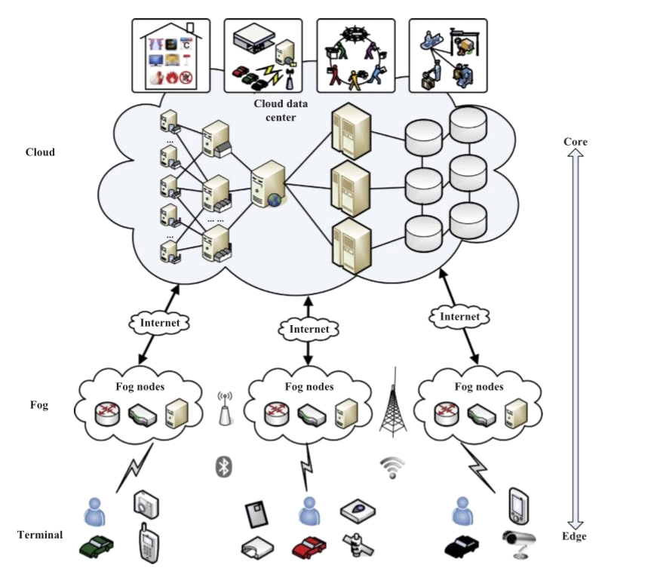

Fig. 1. The hierarchical architecture of Fog Computing [1]

**References:**

[1] P. Hu et al. ‘Survey on Fog Computing: Architecture, Key technologies, Applications, and Open Issues’ , Journal of Networks and Computer Applications 98 (2017), 27-42.

[2] Chiang and Zhang, ‘Fog and IoT: An Overview of Research Opportunities’, IEEE Internet of Things Journal, Vol. 3, No. 6, December 2016

[3] Alessio, Donato, Persico, and Antonio, ‘On the Integration of Cloud Computing and Internet of Things’,

**Prepared by:**

**Asima Nisar (52091) : PhD (CS) candidate**